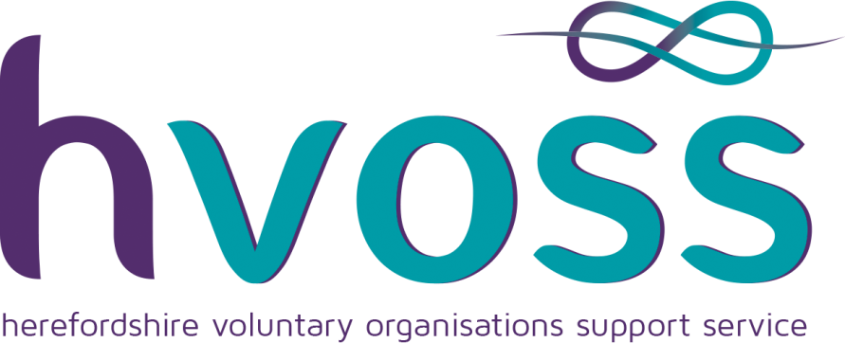

15th October 2010

Focus Group Meting Re New Youth Council for Hereford City Council
14th October 2014 @ Whitecross School

Purpose: to devise a recommendation to Hereford City Council to establish a new model for a Hereford City Youth Council.
Present: William Edwards (HVOSS Youth Development Officer, chair) Denies Strutt, (Headmistress Whitecross High School) Councillor Anna Toon (Hereford City Council & Hereford Skate Park trustee) Jason Borlase (Baptist Church Youth Minister) Apologies Ben Lea (Close House)

An open meeting with free flowing discussion was held to explore an ideal model of youth representation and participation of young people to create a viable youth council structure for Hereford City to adopt. It was agreed that whatever structure be put in place it should facilitate:
- Meaningful engagement to explore issues that impact on Young People within the city
- Influence decision makers – not be tokenistic
- Facilitate shared resources
- Be collaboration promoting and delivering events collectively
- Provide appropriate training foryoung people and councillors.
Age range: It was agreed that there had to be cut off age limits. Through general discussion it was considered that children at Primary school age still had a dependency of parental guidance and that from a Secondary school age there was an more of an expectancy of independent free thinking. It was also agreed that a youth council should include young people attending the sixth form and technical colleges.
Ages recommended were therefore set at: Year 7 at Secondary school age to 19 years.

Representation: Consideration was given to where the young people were selected from Schools; Youth Groups; Uniformed Groups; Sports groups?
Schools; provide formal education including motivation and social responsibility. Representation from a school perspective would be that young people would be cherry picked for their ability to debate and represent the school. Not all pupils would live within the city boundary.
Sports Groups; provide valued positive activities but do not generally have a focus on informal social education
Youth Groups; there is a huge range and variety of provision, some just with a faith based provision other offer open access provision, others provide training and development.
Uniformed Groups/Young Farmers; these groups offer a range of training for new skills with leadership development and consideration to social responsibility.

Through consideration it was agreed that for any youth council to be representational of young people with an ability to relate to youth issues and understand the needs and aspirations of young people. It was considered that recruitment would be best through the open access youth clubs, uniformed groups and faith based youth clubs that offered open access provision, leadership development and social responsibility. A condition of the young people elected would require that they live within the city boundaries. The young people recruited would also attend most of the schools and colleges so these would also be represented though these young people.
Provision should also be made to allow representation from gaps in areas unrepresented such as ethnic minorities, local areas...
Identified Groups:
- Hereford Skate Park
- Close House
- Hereford Baptist Church
- Christian Life Centre
- Police Cadets
- Sea Cadets
- Scouts
- Guides
- St john Ambulance
- Young Farmers

Numbers need to be limited to create purposeful discussions: It was considered that 1 member should represent each group plus provision from identified gaps; this would equate to 10 groups x 2 plus an additional 4 spaces for identified gaps in representation, this would make a total of 14 places.
It was considered that this would be a reasonable number to work with, many more would be unmanageable.

Consultation, the use of social media and the impact and reach of sites such as face book was acknowledged and if facilitated correctly could be invaluable to gain reach and engagement of young people being consulted with.

Schools: It was acknowledged that they could play an invaluable role in supporting reach of young people either through promoting social media consultation but also picking up and responding to relevant issues through school councils.

Conclusions: It was agreed that for any Youth Council to work effectively and meaningful it would need clear aims and objective and Hereford Council would need to adopt a youth policy to acknowledge its engagement

- Act as a two way valve to enable the town council to consult with young people and also be able to respond to identified issues raised from young people.
- Be consulted on Hereford City Council issues to be able to put a youth perspective on all issues and be able to influence decision makers.
- Job descriptions should be drafted for the young people
- Appropriate training for young people to be provided with possibilities and opportunities for young people to develop, possible links through the National Citizenship scheme
- Youth Council to be facilitated by a Youth Worker
- A representative from the City Council to be in attendance at Youth Council meetings to give advice on technical issues.
- The Hereford City Council budget for youth provision for the city to be apportioned through the youth council
- Reach of communication would be disseminated through all youth groups and schools
- Best Practice and Quality Assurance on youth work participation and representation available from HVOSS

