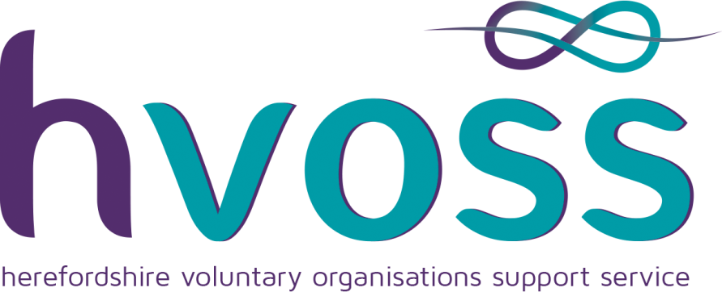

Proposed delivery mechanisms together with a projected budget for the formation and delivery of a new Hereford City Youth Council: for consideration

A focus group meeting was held at Whitecross School to investigate and recommend a proposal for a new youth council; this paper is based on the recommendations of a previous paper which has been circulated to the Council together with other previously circulated papers from HVOSS and Steve Kerry.

Representation: Selection should come from Hereford City based Youth Groups. It is considered that there is a huge range and variety of youth provision, offering training and development for new skills with leadership development and consideration to social responsibility. The council should utilise these skills and resource as representation from these youth groups would be able to relate to youth issues and understand the needs and aspirations of young people. Conditions of the young people elected would require:
- That they live within the city boundaries.
- Age range for representation to be set between Year 7 at Secondary school age to 19 years.
- Job descriptions and roles will be drafted for the young people for them to apply to.
- Provision should also be made allowing representation from gaps in areas unrepresented such as ethnic minorities, local areas...

Suggested Identified Groups to recruit from:
- Hereford Skate Park
- Close House
- Hereford Baptist Church
- Christian Life Centre
- Police Cadets
- Sea Cadets
- Scouts
- Guides
- St john Ambulance
- Young Farmers
- SHYPP
NB this list is not a definitive list but recommended as a starting point
Numbers need to be limited to create purposeful discussions. Membership should represent a good cross section of the population and allowance needs to respond to identified gaps. Proposal is for 11 groups plus an additional 3 spaces for identified gaps in representation, this would make a total of 14 places; more would make the group unmanageable.

Consultation - to maximise the reach, involvement and engagement of young people digital and social media which would enable the impact and reach of participation?

Schools: It was acknowledged that they would play an invaluable role in supporting the reach of young people through consultation and responding to relevant issues through school councils.

Functions of Hereford City Youth Council:
- To meet eight times a year to coincide with Hereford City council meetings and acknowledge the meaningful input of the youth council’s engagement. Venue to be the Town Hall.
- The Hereford City Council to allocate a budget for youth provision for the city to be apportioned through the youth council
- Act as a two way valve to enable the town council to consult with young people and also to respond to identified issues raised by young people.
- Be consulted by Hereford City Council to give a youth perspective on all community/city issues and to be able to influence decision makers.
- Youth Council to be facilitated by an independent non political body (hvoss to supply a suitable Youth Worker)
- A representative from the City Council to be in attendance at Youth Council meetings to give advice on technical issues.
- Reach of communication for consultation would be disseminated through all youth groups and schools via HVOSS co-ordination
- Further possibilities and opportunities for young people to develop youth leadership, social action and training to be promoted such as possible links through the National Citizenship scheme

hvoss cost to provide an independent service to facilitate and support with appropriate mentoring and training Best Practice and Quality Assurance would be:

- Facilitation of a youth council meeting which with a qualified
youth worker including preparation time, £560. 00
8 sessions @ £70 per 2 hour delivery session
- Administration support for communications, setting agenda,
preparing reports and co-ordinating follow up actions
8 sessions @ £50 £400. 00
- Youth work involvement training to city councillors to including
advice and guidance to set up a safeguarding policy and
procedures
1 x 2hour training session @ £60 £ 60. 00
- Youth Leader training to Youth Council members, including roles
and responsibilities, how to discuss and present your point of view
8 sessions @ £70 £560. 00
- Line management and support from hvoss £400. 00

Total annual cost £1,980. 00

William T Edwards
5th January 2015

t: 01432 343932 e: info@hvoss.org.uk w: www.hvoss.org.uk
Herefordshire Voluntary Organisations Support Service (a company limited by guarantee)
Berrows Business Centre, Bath Street, Hereford, HR1 2HE
Registered in England & Wales. Company number: 4625595. Charity number: 1096451.

