JUNIOR MAYOR OF HEREFORD
NOMINATION FORM

Why do we have a Junior Mayor?
- To give a civic presence to a young person representing the young people of the city.
- To encourage young people to take an interest in their city and be involved in helping to make Hereford a better place to live, study and work.
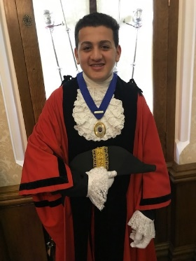
- To help Councillors understand what young people want, what they are concerned about and what they want to do to make improvements.
Who can be Junior Mayor?
- Anyone between the ages of 12 and 17 who either lives or attends full time education in Hereford.
- Parent(s) or guardian(s) must give consent.
- Applications are welcome from any young person, without discrimination.

How do we find a Junior Mayor?
- Nominations are made by schools and youth organisations.
- The Youth Council shortlist nominations and arrange interviews in November with the panel consisting of a youth worker, the Mayor and a Youth Councillor.
- The interviewers will ask about the nominee, why they wish to be considered and what they feel they could bring to the role. Questions from both parties will be welcome.
- The panel will decide the best candidate for the role and a Junior Mayor-Making ceremony will take place in January.
What does the Junior Mayor do?
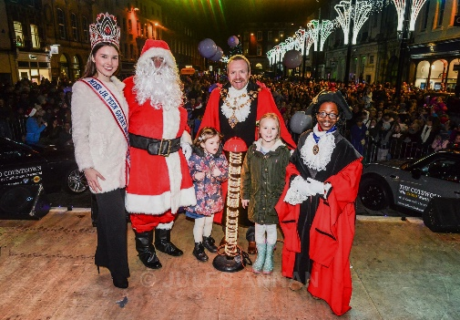
- Attend some major civic events such as the switching on of the Christmas Lights, Remembrance Sunday and the opening of the May Fair (with free rides!).
- Be invited to The Courtyard Christmas Pantomime and to any other events where the Mayor specifically wants a young person to accompany them.
- The Junior Mayor automatically becomes a member of the Youth Council (many have carried on with this as they found it rewarding and interesting).
- Involvement in Youth Council projects such as Knife Angel Hereford, planting an urban orchard, filming a promotional Video, meeting with various local leaders.

What sort of person are we looking for?
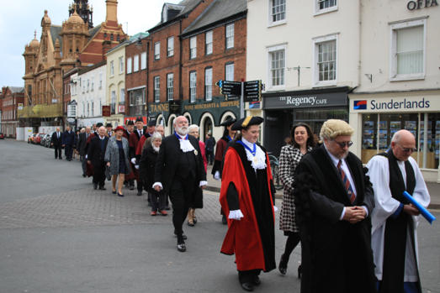
Attendance at Youth Council meetings will be required and to get involved in the big ceremonial events. There will be times when the only young person at an event would be the Junior Mayor, for example on Remembrance Sunday there are a lot of cadets on parade but the only younger person in the civic party with the Mayor and other officials will be the Junior Mayor. This may take some getting used to as there may well be a lot of questions.
On average in any one year there are 10 key events the Junior Mayor will attend and up to a further 10 other Mayoral engagements dependant on the availability of the Junior Mayor.
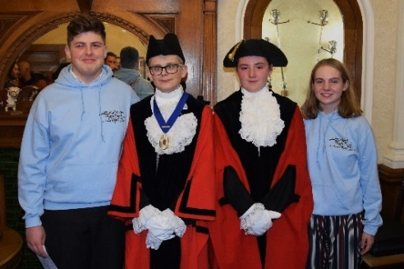
If the nominee has an interest in the local community, or if there has been any involvement in any projects such as community clean ups, environmental projects e.g. habitats for wild animals, or helping disadvantaged families/individuals through schools or any other organisation that would be good to hear about. There will be lots of guidance with things like where to stand and what to do at civic events.
The role will require a certain level of dedication. On average in any one year there are 10 key events the Junior Mayor will attend and up to a further 10 other Mayoral engagements dependant on the availability of the Junior Mayor.

CLOSING DATE FOR APPLICATIONS – THURSDAY 12 DECEMBER

Please return the nomination and parental consent form to:
Lesley Robinson, Mayor’s Secretary
Hereford City Council, Town Hall, Hereford, HR1 2PJ
or email it to: mayor@herefordcitycouncil.gov.uk

Proposer
Name of nominating school or youth organisation:

Name and position of nominator:

Correspondence address:

Telephone number:

Name of nominee for Junior Mayor:

Date of birth:

Please tell us a little bit about your nomination and why you feel they would be a suitable candidate to fulfil the role of Junior Mayor:

Is there any further information you wish to supply in relation to any of the questions above?

Signature of proposer:

Date:
Consent
I (name of parent/guardian)

……………………………………………………………………………………………………………
give consent for (name of young person)

……………………………………………………………………………………………………………
to be nominated/appointed as Junior Mayor of Hereford for one year from January to December.
I understand that as Junior Mayor they will be required to accompany the Mayor of Hereford by arrangement at certain engagements outside school/college hours throughout the year, and that they must be chaperoned always by a responsible adult to be approved by me.

I give permission for photographs to be taken of our charge from time to time, including an official photograph for Hereford City Council records, and for these photographs to be used on occasions by local media, on social media and on the HCC website.

Signature of parent/guardian:

…………………………………………………Date: ………………………………………

Checklist | Yes | No
Does the nominee live or attend full time education in Hereford?
Are they confident and comfortable in the company of adults?
Are they comfortable to take part in civic events (some may require remaining still for several minutes)?
Are they comfortable wearing ceremonial robes and hats?
Will they give a good impression to visitors to the City (dependable, punctual, polite etc)?
Does the nominee have any additional needs?
Consent section completed

